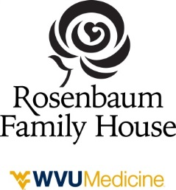
Adopt A Day
The Adopt A Day Program provides friends, families, and guests the opportunity to support the Rosenbaum Family House by sponsoring a special day such as a memorial date, birth date, anniversary date, or other special occasion.
100% of the funds raised from the Adopt A Day program go to the Rosenbaum Family House Care & Comfort Fund. This fund pays the room balance for families in need when all other means have been exhausted
- I am adopting a day at the Rosenbaum Family House for $250 per day.
- I am adopting a week at the Rosenbaum Family House for $1,000 per week.

Name: __________________________________________
Address: _______________________________________
_______________________________________
Phone: _________________________________________
E-mail: __________________________________________
Fill in the message and gift made by information to be published. (Message maximum 25 words.)
Message: ________________________________________________________________________________________
________________________________________________________________________________________
Adopted Date: ____________________________________
Gift made by:_________________________________________________________________

- My check payment of $_________is enclosed.  Mail to:  30 Family House Drive  PO Box 8228  Morgantown, WV 26506 | - I will pay by credit card online at  www.rosenbaumfamilyhouse.com
* Values are an approximate figure that include the materials and services, linens, evening meals, partial utilities and maintenance to operate the 29 guest rooms and eleven apartments for one day at Rosenbaum Family House. Staff salaries and other expenses are not included in this figure.

