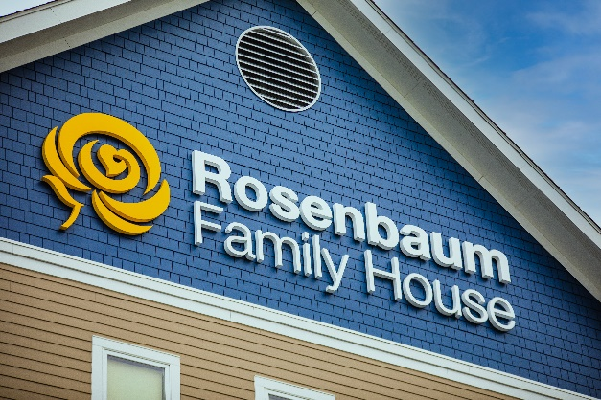

Wish List
Updated 10/17/2023

The needs of our house are no different than yours; our needs are just multiplied by 40 families. Any quantity of any of the items below will help us serve our families during their stay at Family House.

(Please note: We do not use regular toilet paper. We have special dispensers.)

- Hot drink cups (8 oz.) | - Fabric softener sheets
- Cold drink cups (all sizes) | - Disinfectant spray
- Bottled water | - Disinfecting wipes
- Mini toiletry items | - Oatmeal Packets
- Canned foods | - Tea bags
- Pop-tarts or meal bars | - Hot chocolate
- Laundry detergent | - Regular or Decaf coffee
- Individual packets of coffee creamer | - Coffee stirrers
- Individual packets of sugar packets or other sweeteners | - Individual size frozen meals  - Aluminum foil serving pans
- Packaged snacks | - Sturdy paper plates/bowls
- Plastic silverware | - Bleach
- Sturdy dessert plates | - Paper towels
- Vinyl gloves | - Cooking utensils
- Universal remote controls and batteries | - Gift Cards (Sam’s Club/Walmart)
- Serving utensils | - Copy paper and post-it notes
Follow us on Facebook at Rosenbaum FamilyHouse to see our immediate needs via our #WishListWednesday posts.

30 Family House Drive PO Box 8228 Morgantown, WV 26506

For more information, or to make a donation, please
contact us at 304-598-6094, Opt. 1

